Project : Point of Sale (ePOS) System

**Version 1.0**

**Revision History**

| **Date** | **Version** | **Description** | **Author** |
| --- | --- | --- | --- |
| 2024-02-28 | 1.0 | Initial SRS Document | Raihan Khan |

The objective of this project is to develop a user-friendly and secure Point of Sale (ePOS) system for businesses to manage sales, inventory, and customer interactions in a retail or hospitality environment. The system will be a web-based application, offering features like sales processing, inventory management, customer data management, reporting, and analytics.

**Please note** - Requirement documentation contains details on user stories, test cases, and design mockups to each requirement to provide more clarity and context for the development team.

The project will aim to improve operational efficiency, enhance customer satisfaction, and provide real-time insights into sales and inventory for business owners. The target audience for the ePOS system includes small to medium-sized retail stores, cafes, and restaurants looking to digitize their sales and inventory management processes.

| **Requirement** |  | **Description** | **Priority** | **Acceptance Criteria** |
| --- | --- | --- | --- | --- |
| 1.Login | Admin | should be able to log in to the system securely. | High | - Admin can access the login page from the system homepage.<br>- Admin can enter their credentials and click the "login" button.<br>- Admin is redirected to their dashboard upon successful login. |
|  | Staff |  | High | - Staff can access the login page from the system homepage.<br>- Staff can enter their credentials and click the "login" button.<br>- Staff is redirected to their dashboard upon successful login. |
| Sales Processing | Admin & Staff | should be able to process sales transactions. | High | - Admin & Staff can add products to a sale by scanning a barcode or searching for items. <br> - The system calculates the total cost, including taxes. <br> - Employee can finalize the sale and choose the payment method. |
| Inventory Management | Admin Admin & Staff | should be able to manage inventory. | High | - Manager can add new products to the inventory. <br> - Manager can update stock levels and product details. <br> - The system provides alerts for low stock levels. |
| Customer Management | Admin & Staff | should be able to manage customer data. | Medium | - Employees can create new customer profiles. <br> - Employee can update customer information and view purchase history. <br> - The system can track customer loyalty points. |
| Reporting and Analytics | Admin | should have access to sales and inventory reports. | High | - Admin can generate sales reports for specific periods.<br>- Admin can view inventory levels and order history reports.<br>- The system offers insights into sales trends and product performance. |
| Reporting and Analytics | Staff | should have access to should have access to sales and inventory reports. | Medium | - Staff can view and generate inventory reports for specific periods. |
| Expired Notification | Admin | should be notified of product expiration to ensure timely actions can be taken. | Medium | - Admin can access the expired product notification section from their dashboard. <br> - System generates notifications for products reaching expiration based on predefined thresholds. <br> - The system maintains a history of expired product notifications for reference. |
| Expired Notification | Staff | should be notified of product expiration to ensure timely actions can be taken. | Medium | - The system maintains a history of expired product notifications for reference. <br> -stuff can generate expired reports list of products. |

### 

### 

### Login

**User Stories**

- As an admin, I want to securely log in to the POS system to access administrative functions and manage store operations effectively.

- As a staff member, I want to securely log in to the POS system to process sales and manage inventory during my shift.

**Design Mockups**

Login page design mockup

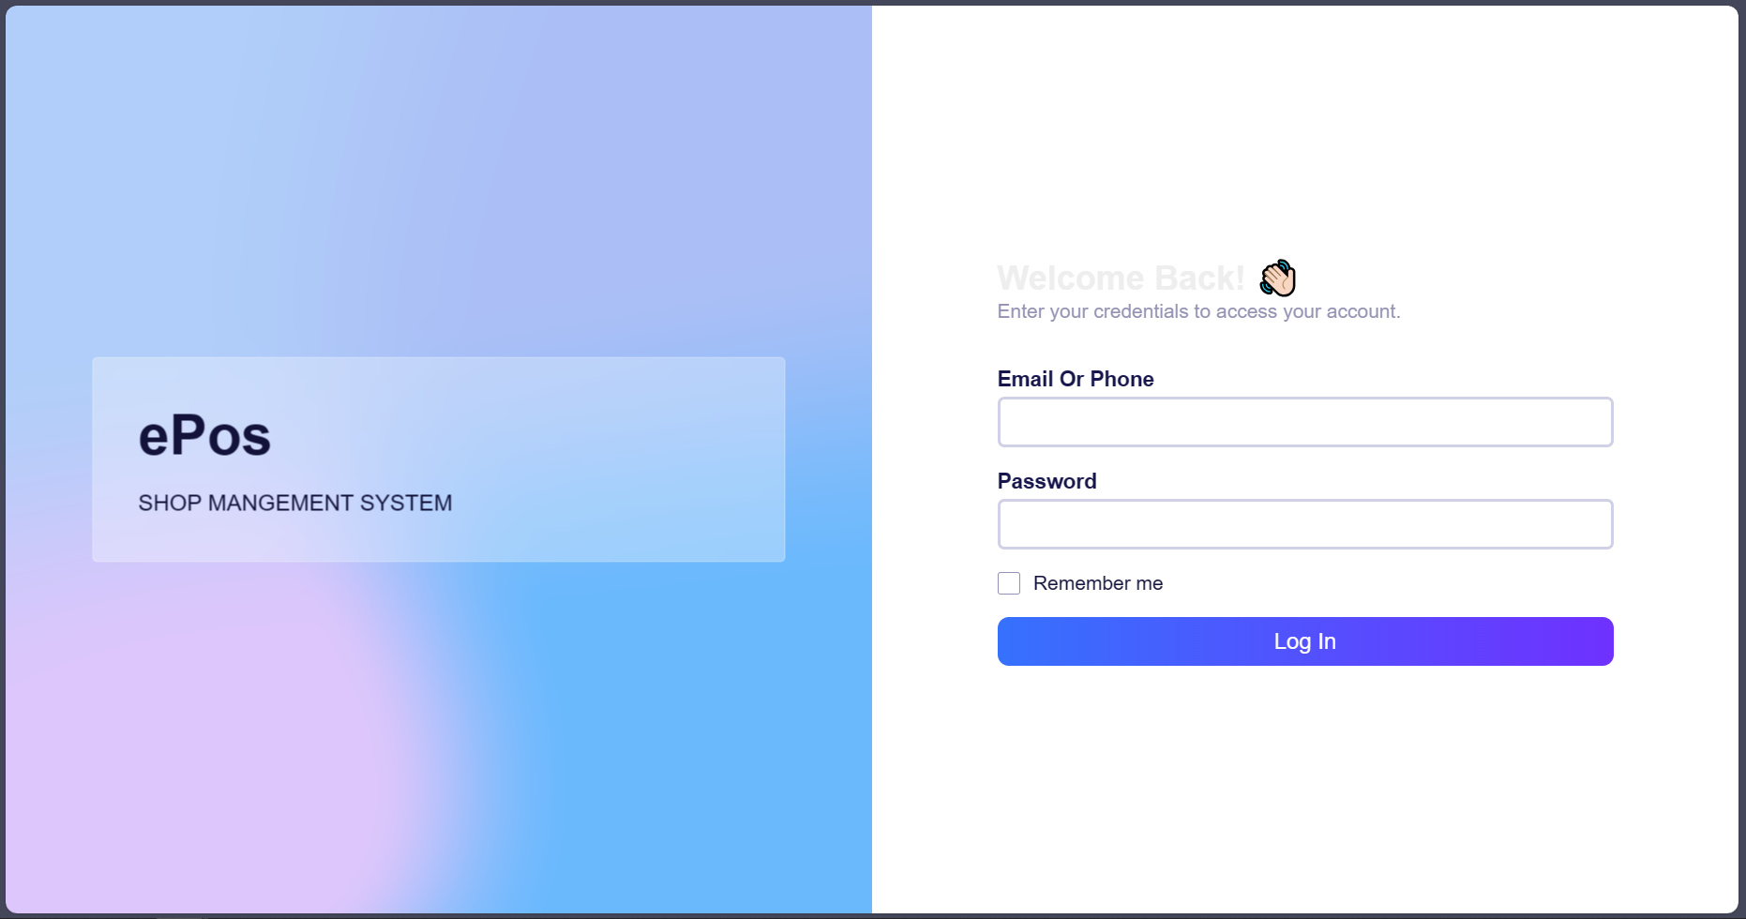

### Sales Processing

User Stories

- As an admin, I want to be able to process sales transactions by adding products, calculating total costs, and finalizing sales.

- As a staff member, I want to assist in processing sales transactions by adding products, calculating total costs, and finalizing sales accurately and efficiently.

Sales processing page design mockup

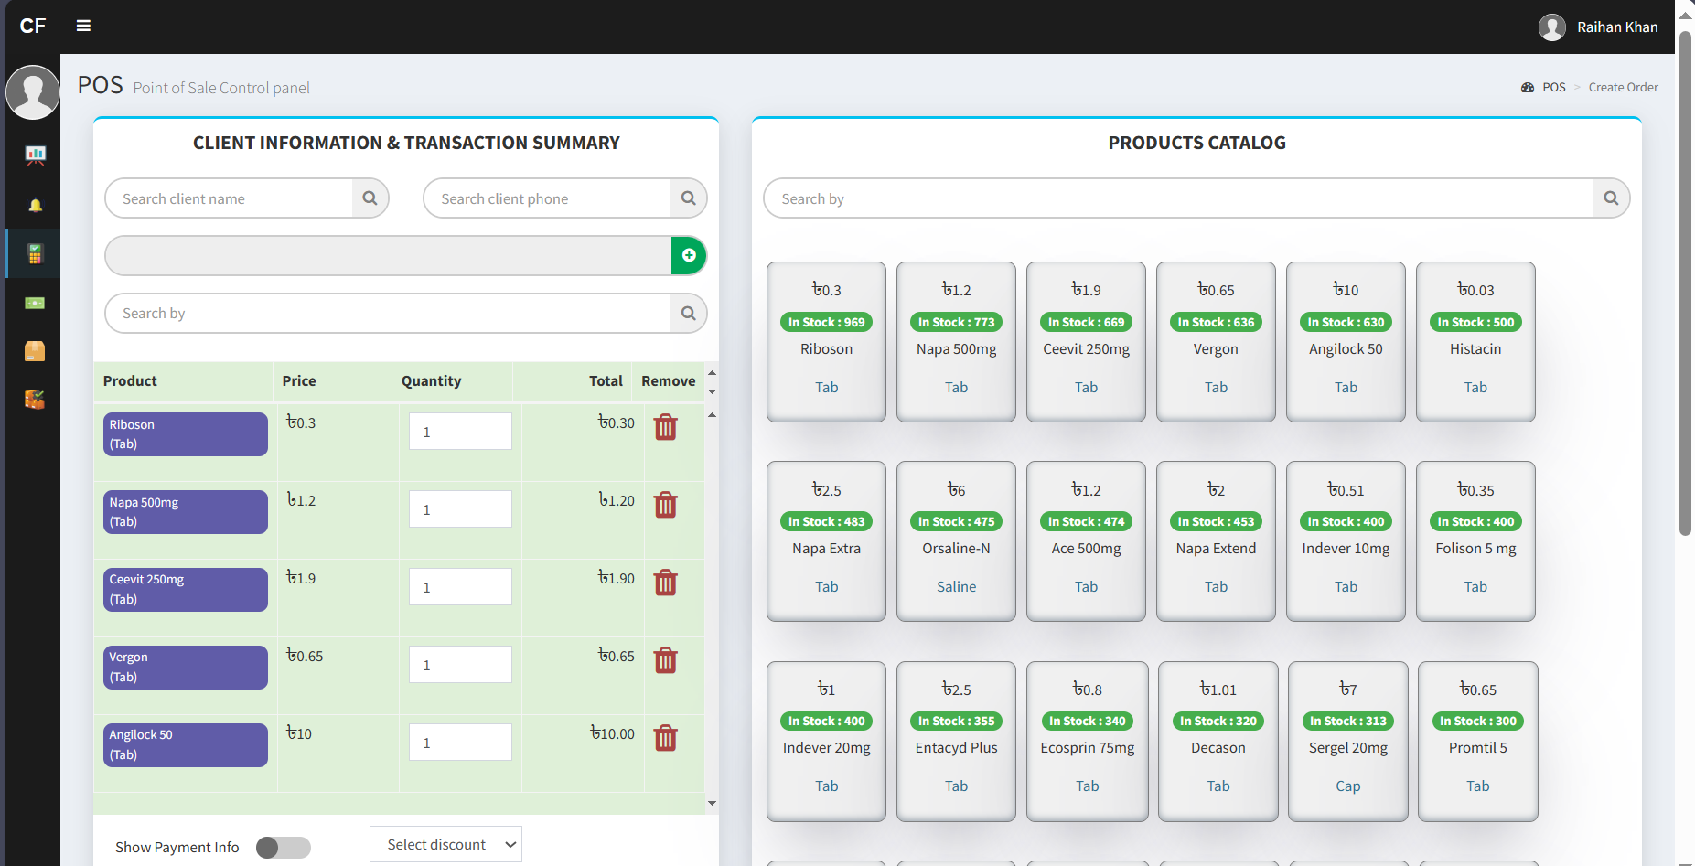

### 

### Inventory Management

User Stories

As an admin, I want to manage inventory by adding new products, updating stock levels, and receiving alerts for low stock to ensure efficient stock management.

- As a staff member, I want to support inventory management by updating stock levels and receiving alerts for low stock to ensure products are always available for customers.

- As a stuff , I want to easily add and update product information in the inventory.

Design Mockups

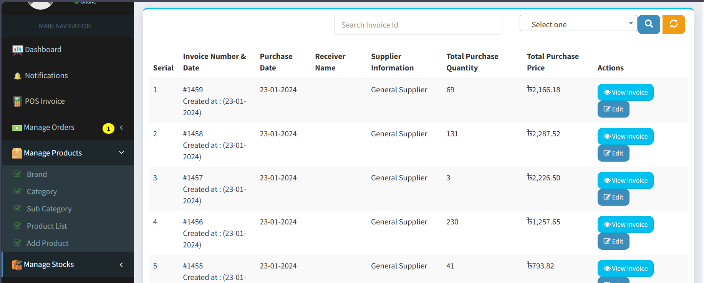

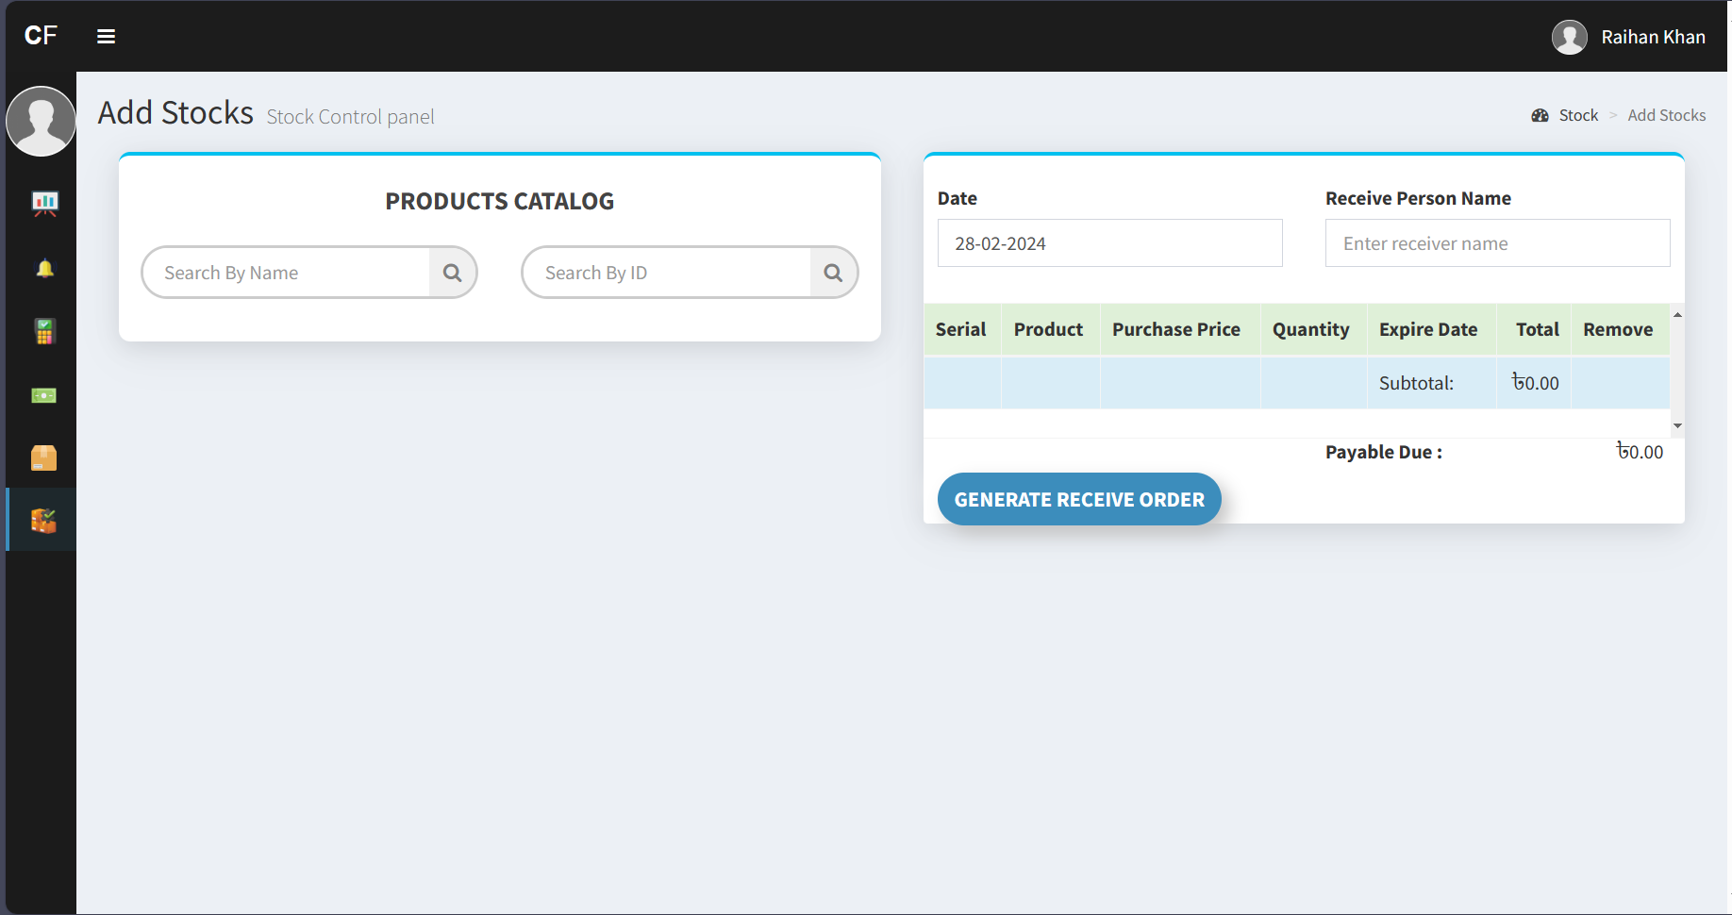

### Customer Management

User Stories

- As an admin, I want to handle customer data by creating new customer profiles, updating information, and tracking loyalty points to enhance customer satisfaction and retention.

- As a staff member, I want to contribute to managing customer data by updating information and viewing purchase history to provide personalized service.

- as defaults customer role by “walk-in customer”

Customer page design mockup

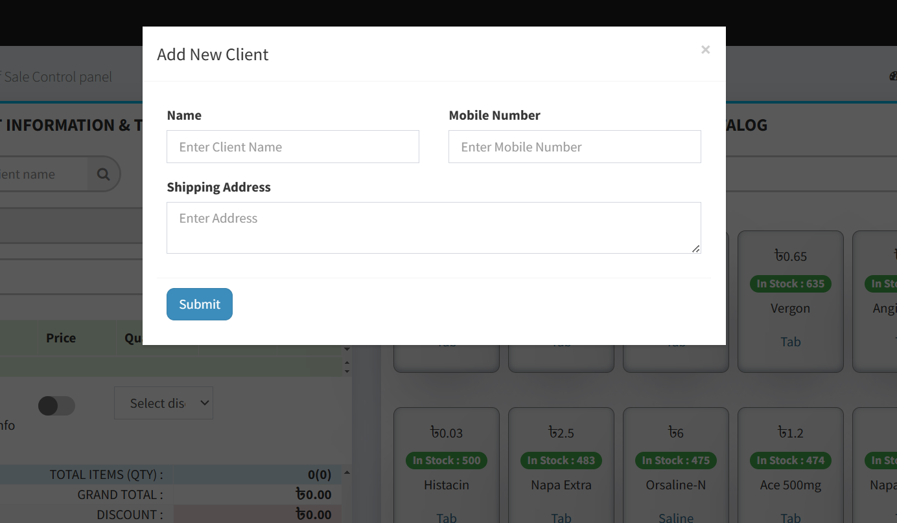

### Reporting and Analytics

User Stories

- As an admin, I want to access comprehensive sales and inventory reports to analyze business performance and make informed decisions.

- As a staff member, I want to access inventory reports for specific periods to assist in managing inventory effectively during shifts.

Design Mockups:

- Reporting and analytics dashboard design mockup

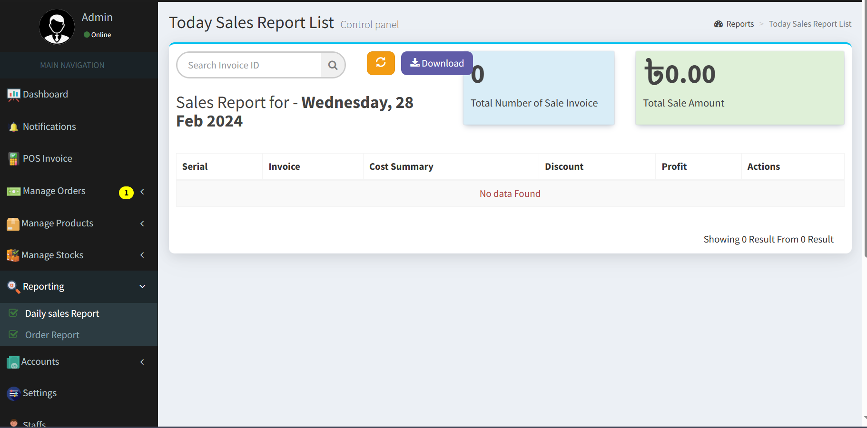

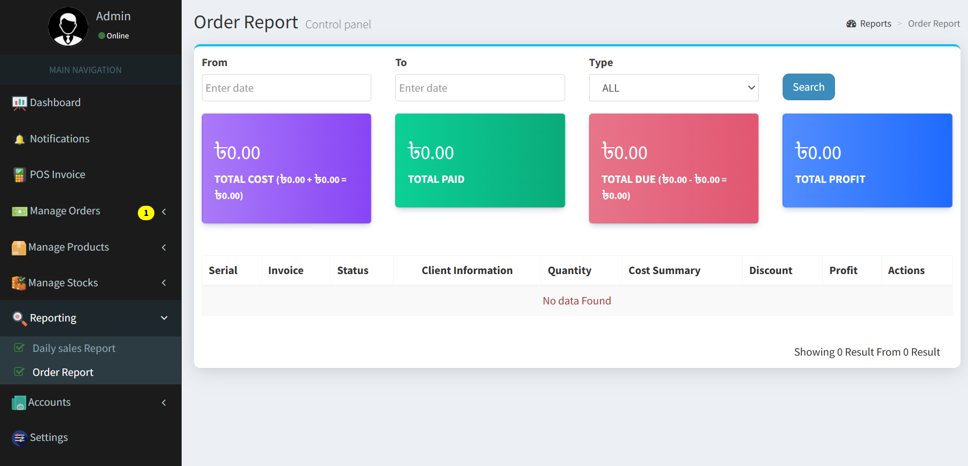

### Expired Product Notification

User Stories

- As an admin, I want to receive notifications for product expiration to take timely actions and maintain product quality.

- As a staff member, I want to receive notifications for product expiration to ensure timely actions and maintain product quality.

